**Отчёт по выполнению Лабораторной работы №2**

Выполнил студент Семенов Дмитрий, группа ПМИ-РКС-20

Таблицы БД

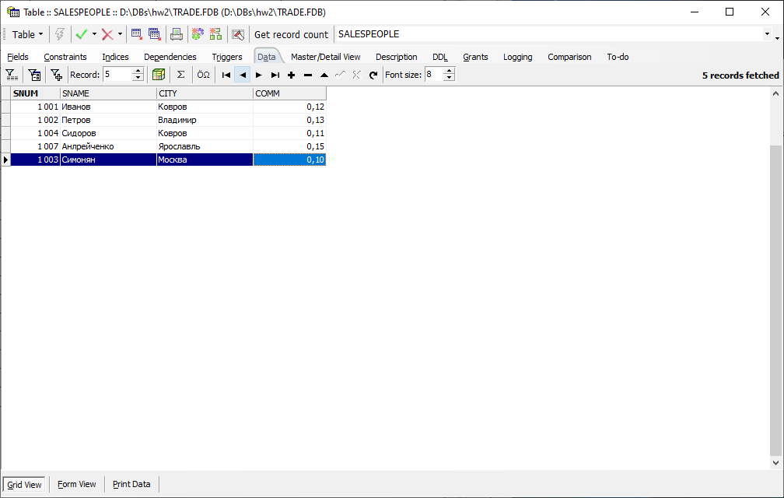

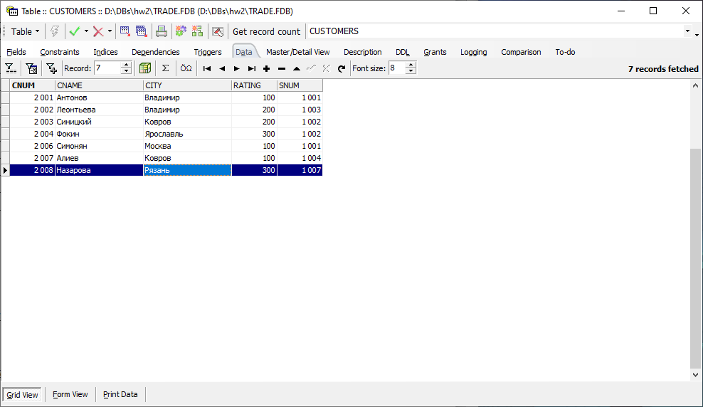

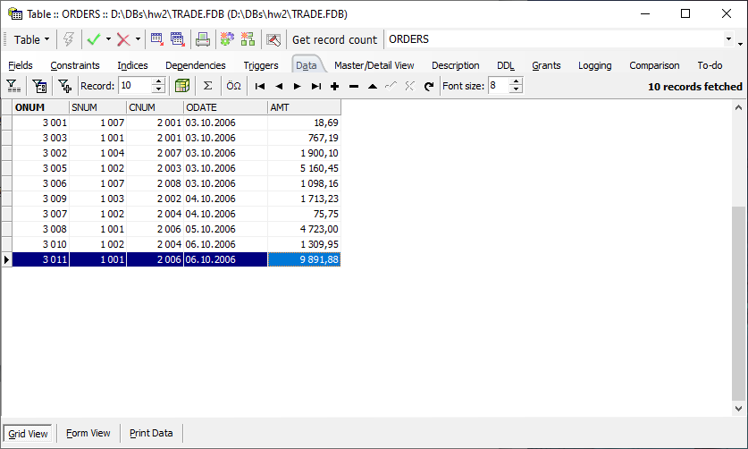

1.1 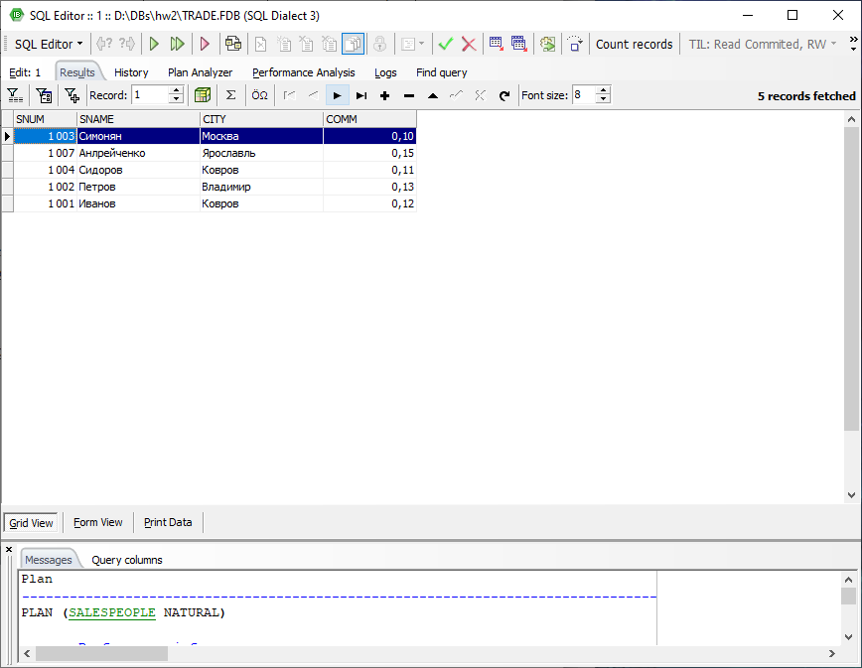1.2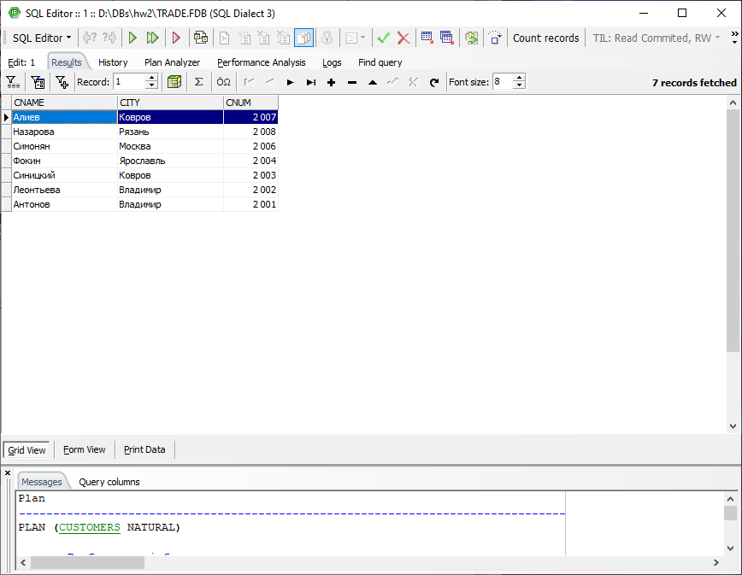

1.3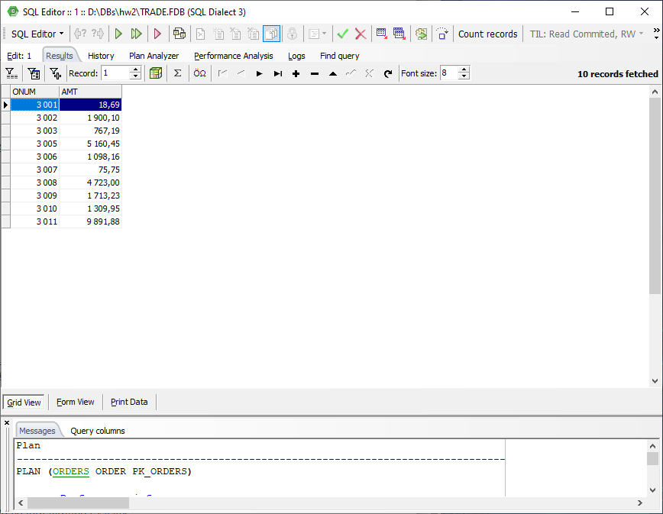 1.4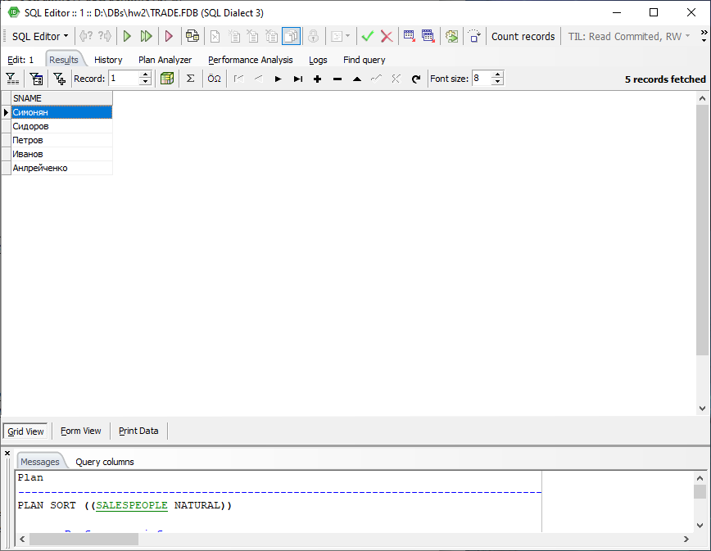2.1 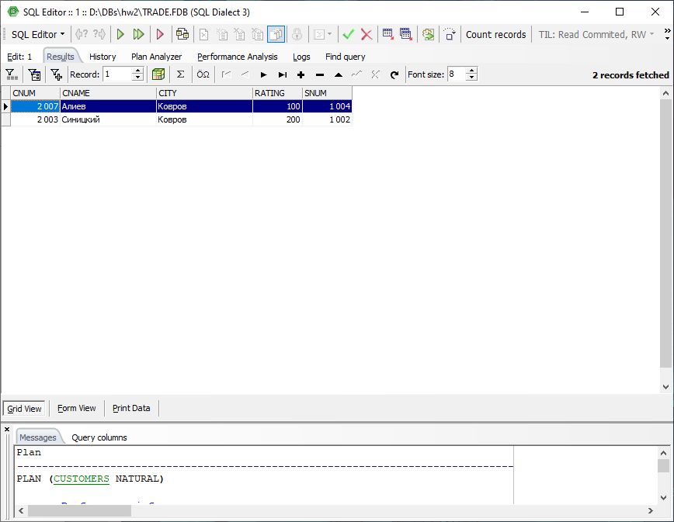 2.2

select *

from customers

where city != 'Ковров'

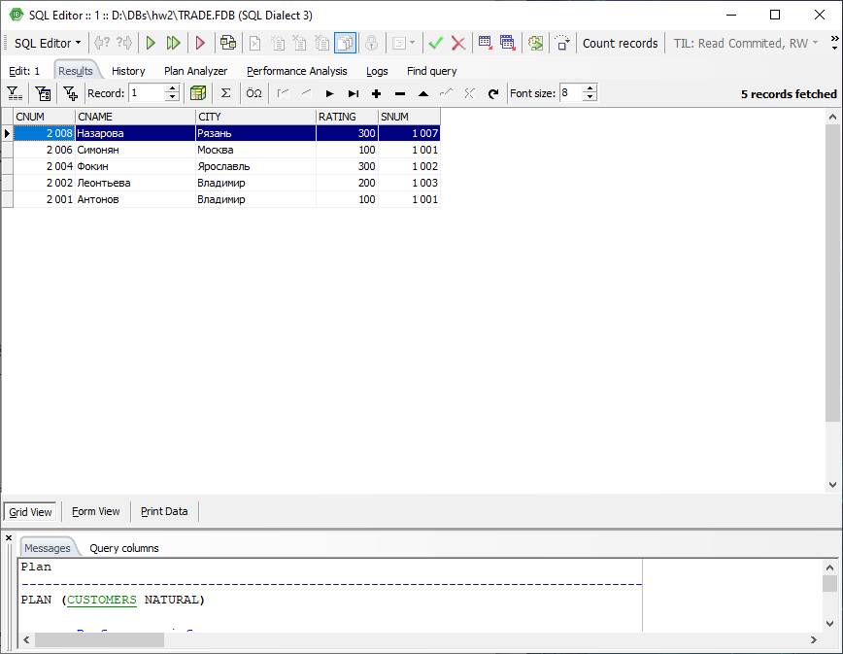

2.3 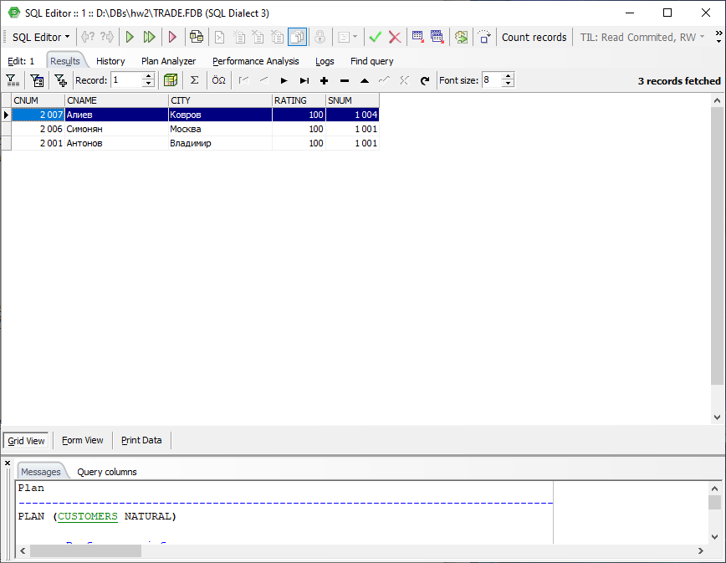

2.4 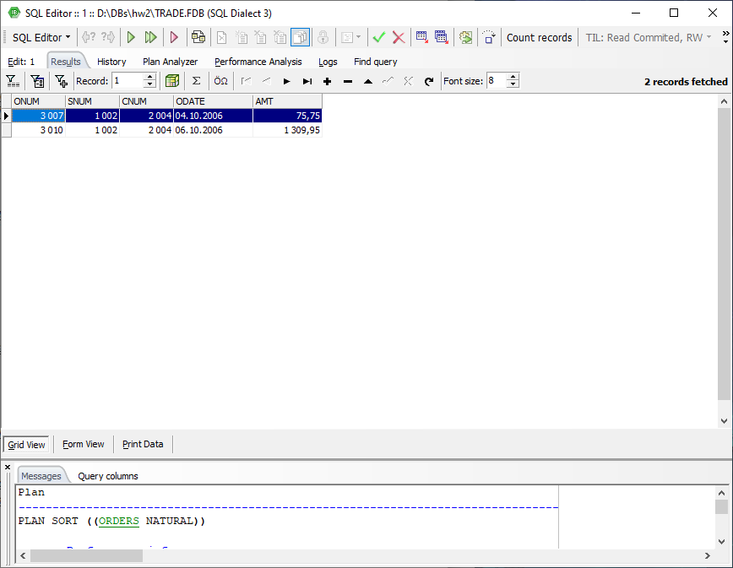2.5

select *

from orders

where odate = '03.10.2006' or odate = '04.10.2006'

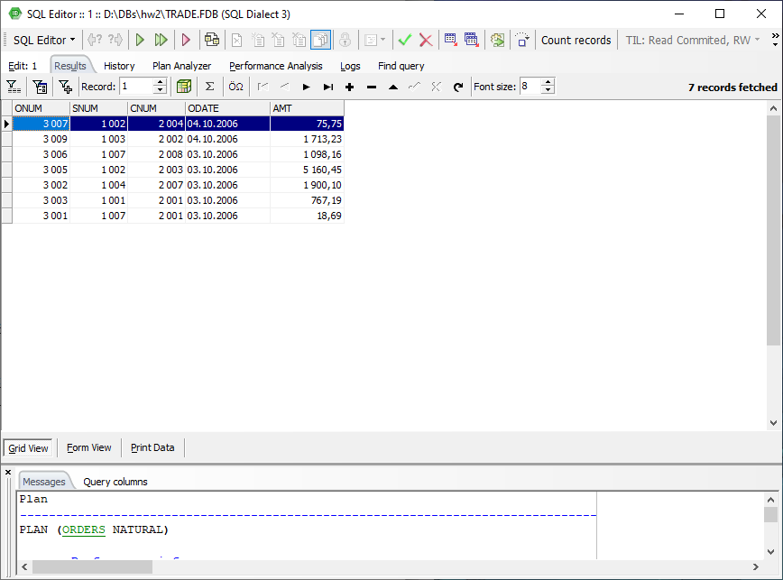

select *

from orders

where odate in ('03.10.2006', '04.10.2006')

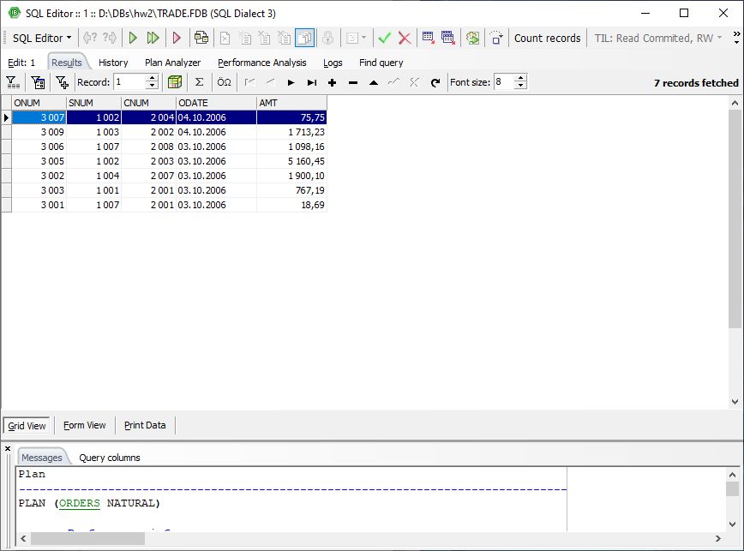

3.1 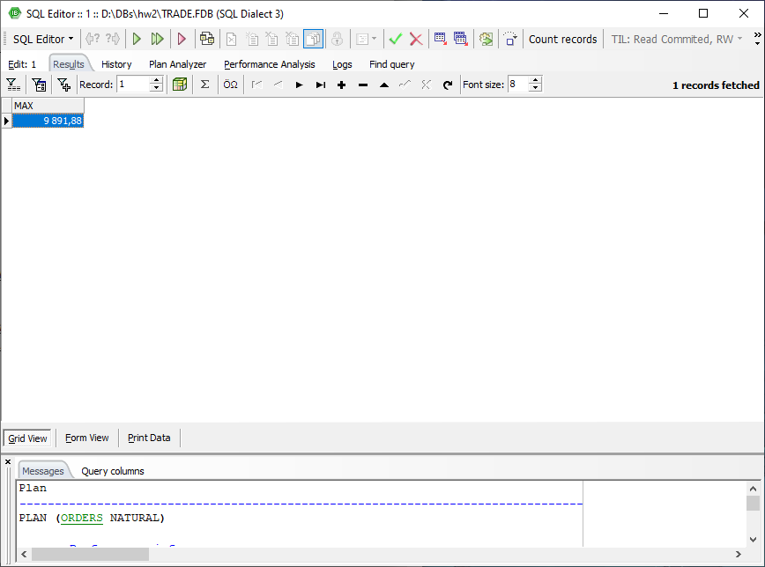

3.2 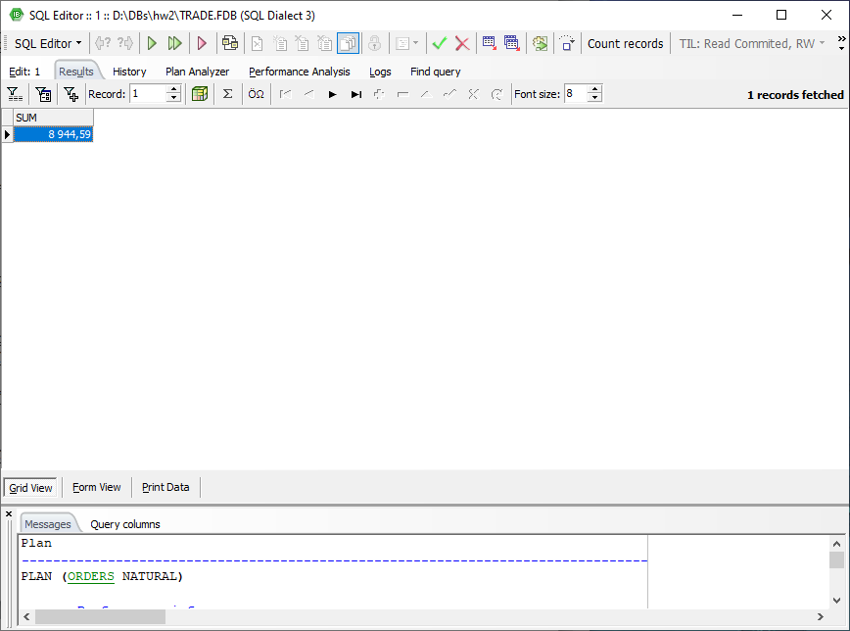

3.3

select min(amt)

from orders

where cnum = 2008

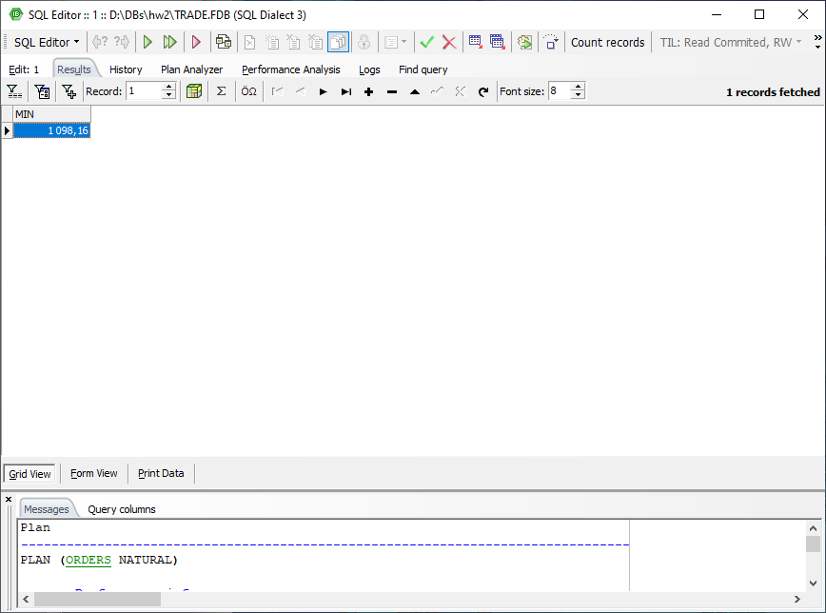

3.4

select avg(amt)

from orders

where cnum = 2003 or cnum = 2007

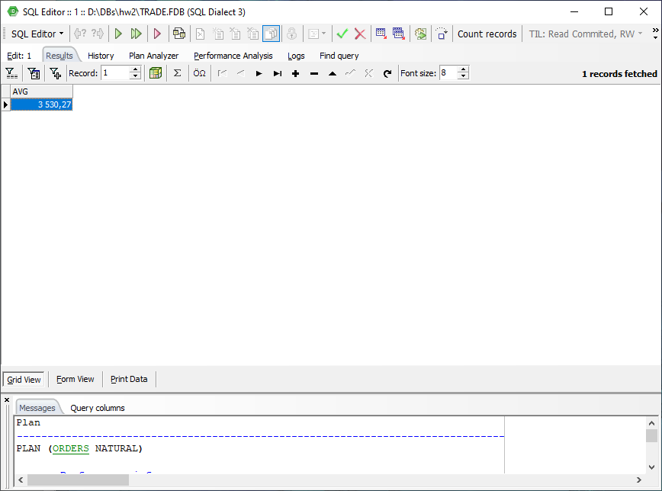

4.1 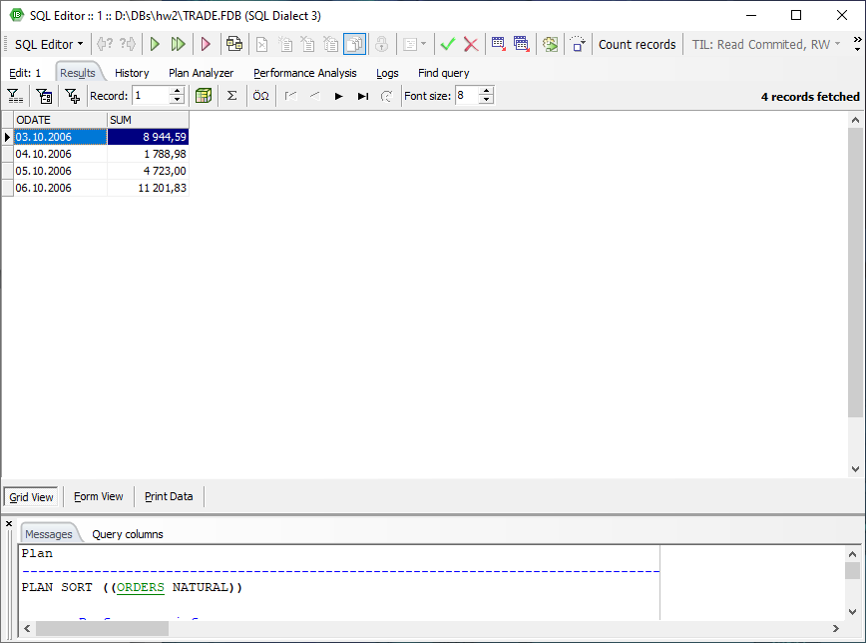

4.2

select snum, count(snum)

from orders

group by snum

order by snum

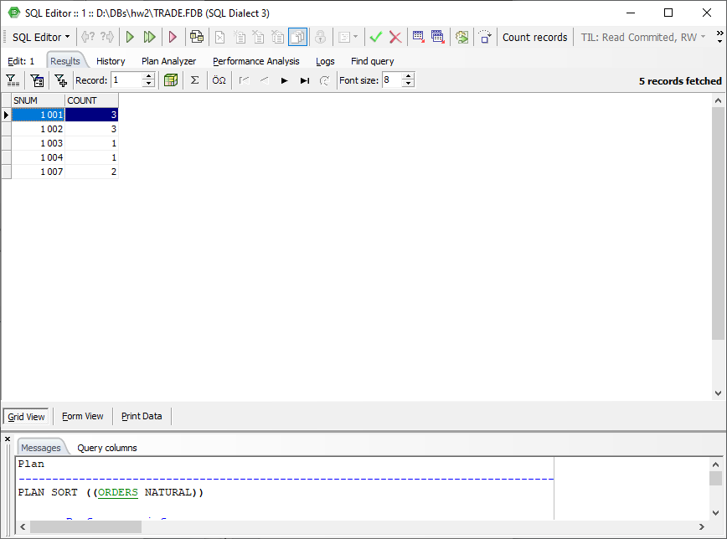

5.1

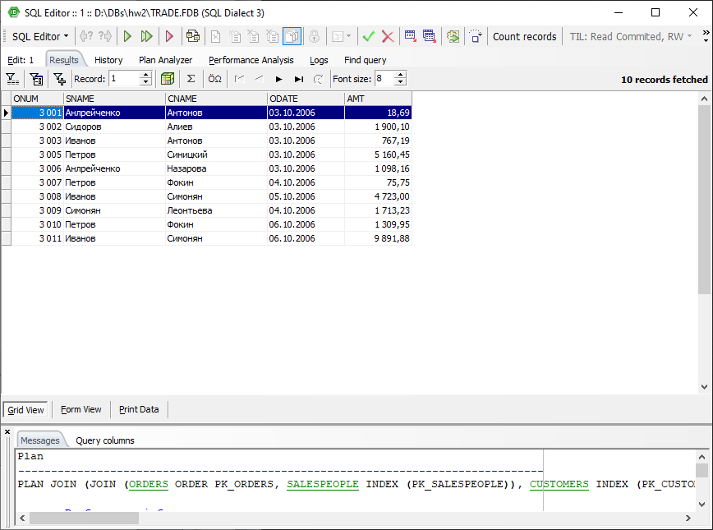

5.2

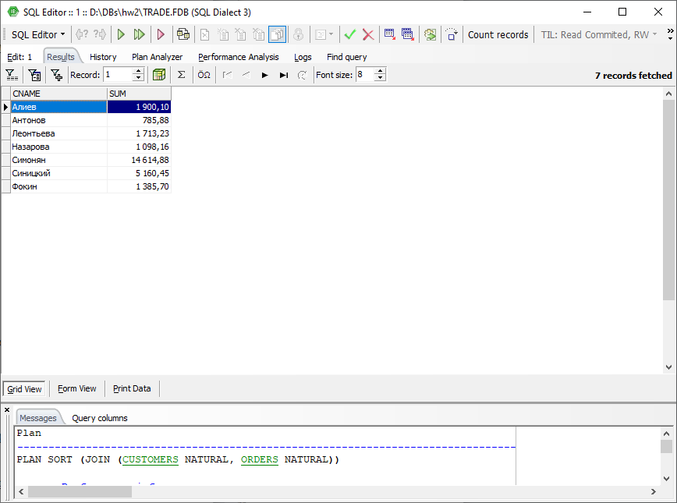

5.3

select salespeople.sname, max(orders.amt)

from salespeople

left outer join orders on salespeople.snum = orders.snum

group by salespeople.sname

order by salespeople.sname

